Chapter 4: Transmission Media

- Introduction
Transmission media can be defined as physical path between transmitter and receiver in a data transmission system. And it may be classified into two types as shown in Fig. 1.

- Guided: Transmission capacity depends critically on the medium, the length, and whether the medium is point-to-point or multipoint (e.g. LAN). Examples are co-axial cable, twisted pair, and optical fiber.

- Unguided: provides a means for transmitting electro-magnetic signals but do not guide them. Example wireless transmission.

Characteristics and quality of data transmission are determined by medium and signal characteristics. For guided media, the medium is more important in determining the limitations of transmission. While in case of unguided media, the bandwidth of the signal produced by the transmitting antenna and the size of the antenna is more important than the medium. Signals at lower frequencies are omni-directional (propagate in all directions). For higher frequencies, focusing the signals into a directional beam is possible. These properties determine what kind of media one should use in a particular application. In this lesson we shall discuss the characteristics of various transmission media, both guided and unguied.
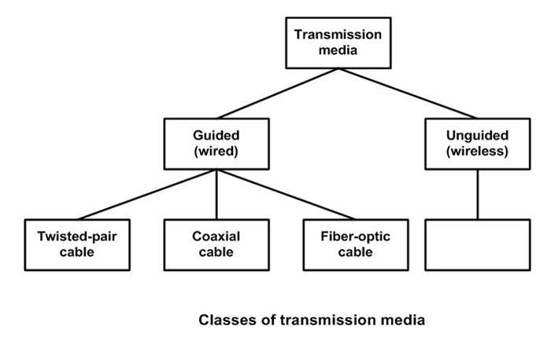

Atmosphere

Figure 1 Classification of the transmission media

- Guided transmission media

In this section we shall discuss about the most commonly used guided transmission media such as twisted-pair of cable, coaxial cable and optical fiber.

1. Twisted Pair
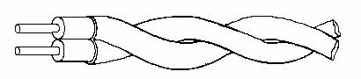

Figure 2 CAT5 cable (twisted cable)

In twisted pair technology, two copper wires are strung between two points:

- The two wires are typically ``twisted'' together in a helix to reduce interference between the two conductors as shown in Fig. 2. Twisting decreases the cross-talk interference between adjacent pairs in a cable. Typically, a number of pairs are bundled together into a cable by wrapping them in a tough protective sheath.

- Can carry both analog and digital signals. Actually, they carry only analog signals. However, the ``analog'' signals can very closely correspond to the square

waves representing bits, so we often think of them as carrying digital data.

- Data rates of several Mbps common.

- Spans distances of several kilometers.

- Data rate determined by wire thickness and length. In addition, shielding to eliminate interference from other wires impacts signal-to-noise ratio, and ultimately, the data rate.

- Good, low-cost communication. Indeed, many sites already have twisted pair installed in offices -- existing phone lines!

Typical characteristics: Twisted-pair can be used for both analog and digital communication. The data rate that can be supported over a twisted-pair is inversely proportional to the square of the line length. Maximum transmission distance of 1 Km can be achieved for data rates up to 1 Mb/s. For analog voice signals, amplifiers are required about every 6 Km and for digital signals, repeaters are needed for about 2 Km. To reduce interference, the twisted pair can be shielded with metallic braid. This type of wire is known as Shielded Twisted-Pair (STP) and the other form is known as Unshielded Twisted-Pair (UTP).

Use: The oldest and the most popular use of twisted pair are in telephony. In LAN it is commonly used for point-to-point short distance communication (say, 100m) within a building or a room.

2. Base band Coaxial

With ``coax'', the medium consists of a copper core surrounded by insulating material and a braided outer conductor as shown in Fig. 3. The term base band indicates digital transmission (as opposed to broadband analog).

Insulator | Braided Outer | Protective
Copper | Conductor | Plastic
Wire |  | Covering
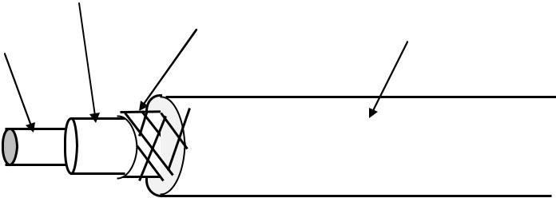

Figure 3 Co-axial cable

Physical connection consists of metal pin touching the copper core. There are two common ways to connect to a coaxial cable:

- With vampire taps, a metal pin is inserted into the copper core. A special tool drills a hole into the cable, removing a small section of the insulation, and a special connector
is screwed into the hole. The tap makes contact with the copper core.

- With a T-junction, the cable is cut in half, and both halves connect to the T-junction. A T-connector is analogous to the signal splitters used to hook up multiple TVs to the same cable wire.

Characteristics: Co-axial cable has superior frequency characteristics compared to twisted-pair and can be used for both analog and digital signaling. In baseband LAN, the data rates lies in the range of 1 KHz to 20 MHz over a distance in the range of 1 Km. Co-axial cables typically have a diameter of 3/8". Coaxial cables are used both for baseband and broadband communication. For broadband CATV application coaxial cable of 1/2"

diameter and 75 Ω impedance is used. This cable offers bandwidths of 300 to 400 MHz facilitating high -speed data communication with low bit-error rate. In broadband signaling, signal propagates only in one direction, in contrast to propagation in both directions in baseband signaling. Broadband cabling uses either dual-cable scheme or single -cable scheme with a headend to facilitate flow of signal in one direction. Because of the shielded, concentric construction, co-axial cable is less susceptible to interference and cross talk than the twisted-pair. For long distance communication, repeaters are needed for every kilometer or so. Data rate depends on physical properties of cable, but 10 Mbps is typical.

Use: One of the most popular use of co-axial cable is in cable TV (CATV) for the distribution of TV signals. Another importance use of co-axial cable is in LAN.

3. Broadband Coaxial

The term broadband refers to analog transmission over coaxial cable. (Note, however, that the telephone folks use broadband to refer to any channel wider than 4 kHz). The technology:

- Typically bandwidth of 300 MHz, total data rate of about 150 Mbps.

- Operates at distances up to 100 km (metropolitan area!).
- Uses analog signaling.
- Technology used in cable television. Thus, it is already available at sites such as universities that may have TV classes.
- Total available spectrum typically divided into smaller channels of 6 MHz each. That is, to get more than 6MHz of bandwidth, you have to use two smaller channels and somehow combine the signals.
- Requires amplifiers to boost signal strength; because amplifiers are one way, data flows in only one direction.

Two types of systems have emerged:

1. Dual cable systems use two cables, one for transmission in each direction: o One cable is used for receiving data.

  - Second cable used to communicate with headend. When a node wishes to transmit data, it sends the data to a special node called the headend. The headend then resends the data on the first cable. Thus, the headend acts as a root of the tree, and all data must be sent to the root for redistribution to the other nodes.

- Midsplit systems divide the raw channel into two smaller channels, with each sub channel having the same purpose as above.

Which is better, broadband or base band? There is rarely a simple answer to such questions. Base band is simple to install, interfaces are inexpensive, but doesn't have the same range. Broadband is more complicated, more expensive, and requires regular adjustment by a trained technician, but offers more services (e.g., it carries audio and video too).
4. Fiber Optics

In fiber optic technology, the medium consists of a hair-width strand of silicon or glass, and the signal consists of pulses of light. For instance, a pulse of light means ``1'', lack of pulse means ``0''. It has a cylindrical shape and consists of three concentric sections: the core, the cladding, and the jacket as shown in Fig. 4.
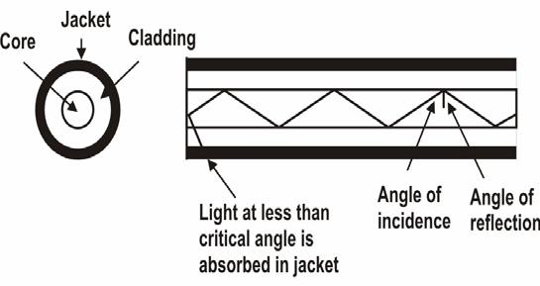

Figure 4 Optical Fiber

The core, innermost section consists of a single solid dielectric cylinder of diameter d₁ and of refractive index n₁. The core is surrounded by a solid dielectric cladding of refractive index n₂ that is less than n₁. As a consequence, the light is propagated through multiple total internal reflection. The core material is usually made of ultra pure fused silica or glass and the cladding is either made of glass or plastic. The cladding is surrounded by a jacket made of plastic. The jacket is used to protect against moisture, abrasion, crushing and other environmental hazards.

Three components are required:

- Fiber medium: Current technology carries light pulses for tremendous distances (e.g., 100s of kilometers) with virtually no signal loss.
- Light source: typically a Light Emitting Diode (LED) or laser diode. Running current through the material generates a pulse of light.

- A photo diode light detector, which converts light pulses into electrical signals.

Advantages:

- Very high data rate, low error rate. 1000 Mbps (1 Gbps) over distances of kilometers common. Error rates are so low they are almost negligible.
- Difficult to tap, which makes it hard for unauthorized taps as well. This is responsible for higher reliability of this medium.

How difficult is it to prevent coax taps? Very difficult indeed, unless one can keep the entire cable in a locked room!

- Much thinner (per logical phone line) than existing copper circuits. Because of its thinness, phone companies can replace thick copper wiring with fibers having much more capacity for same volume. This is important because it means that aggregate phone capacity can be upgraded without the need for finding more physical space to hire the new cables.

- Not susceptible to electrical interference (lightning) or corrosion (rust).

- Greater repeater distance than coax.

Disadvantages:

- Difficult to tap. It really is point-to-point technology. In contrast, tapping into coax is trivial. No special training or expensive tools or parts are required.

- One-way channel. Two fibers needed to get full duplex (both ways) communication.

Optical Fiber works in three different types of modes (or we can say that we have 3 types of communication using Optical fiber). Optical fibers are available in two varieties;

Multi-Mode Fiber (MMF) and Single-Mode Fiber (SMF). For multi-mode fiber the core and cladding diameter lies in the range 50-200μm and 125-400μm, respectively. Whereas in single-mode fiber, the core and cladding diameters lie in the range 8-12μm and 125μm, respectively. Single-mode fibers are also known as Mono-Mode Fiber. Moreover, both single-mode and multi-mode fibers can have two types; step index and graded index. In the former case the refractive index of the core is uniform throughout and at the core cladding boundary there is an abrupt change in refractive index. In the later case, the refractive index of the core varies radially from the centre to the core-cladding boundary from n₁ to n₂ in a linear manner. Fig. 5 shows the optical fiber transmission modes.
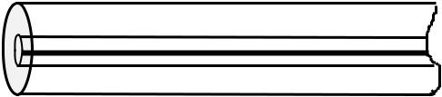
(a)
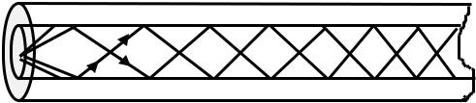

(b)
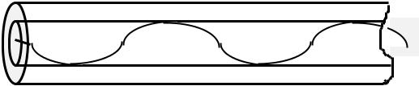

(c)

Figure 5 Schematics of three optical fiber types, (a) Single-mode step-index, (b) Multi-mode step-index, and (c) Multi-mode graded-index
Characteristics: Optical fiber acts as a dielectric waveguide that operates at optical frequencies (10¹⁴ to 10¹⁵ Hz). Three frequency bands centered around 850,1300 and 1500 nanometers are used for best results. When light is applied at one end of the optical fiber core, it reaches the other end by means of total internal reflection because of the choice of refractive index of core and cladding material (n₁ > n₂). The light source can be either light emitting diode (LED) or injection laser diode (ILD) . These semiconductor devices emit a beam of light when a voltage is applied across the device. At the receiving end, a photodiode can be used to detect the signal- encoded light. Either PIN detector or APD (Avalanche photodiode) detector can be used as the light detector.

In a multi-mode fiber, the quality of signal-encoded light deteriorates more rapidly than single-mode fiber, because of interference of many light rays. As a consequence, single-mode fiber allows longer distances without repeater. For multi- mode fiber, the typical maximum length of the cable without a repeater is 2km, whereas for single-mode fiber it is 20km.

Fiber Uses: Because of greater bandwidth (2Gbps), smaller diameter, lighter weight, low attenuation, immunity to electromagnetic interference and longer repeater spacing, optical fiber cables are finding widespread use in long-distance telecommunications. Especially, the single mode fiber is suitable for this purpose. Fiber optic cables are also used in high-speed LAN applications. Multi-mode fiber is commonly used in LAN.

- Long-haul trunks-increasingly common in telephone network (Sprint ads)

- Metropolitan trunks-without repeaters (average 8 miles in length)
- Rural exchange trunks-link towns and villages
- Local loops-direct from central exchange to a subscriber (business or home)

- Local area networks-100Mbps ring networks.

- Unguided Transmission

Unguided transmission is used when running a physical cable (either fiber or copper) between two end points is not possible. For example, running wires between buildings is probably not legal if the building is separated by a public street.

Infrared signals typically used for short distances (across the street or within same room),

Microwave signals commonly used for longer distances (10's of km). Sender and receiver use some sort of dish antenna as shown in Fig. 6.

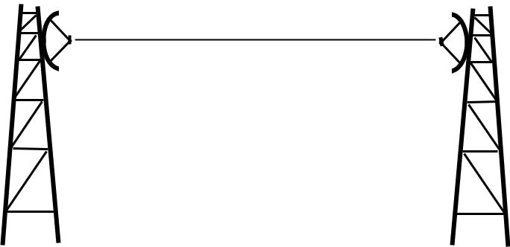

Figure 6 Communication using Terrestrial Microwave

Difficulties:

- Weather interferes with signals. For instance, clouds, rain, lightning, etc. may adversely affect communication.
- Radio transmissions easy to tap. A big concern for companies worried about competitors stealing plans.
- Signals bouncing off of structures may lead to out-of-phase signals that the receiver must filter out.

Satellite Communication

Satellite communication is based on ideas similar to those used for line-of-sight. A communication satellite is essentially a big microwave repeater or relay station in the sky. Microwave signals from a ground station is picked up by a transponder, amplifies the signal and rebroadcasts it in another frequency, which can be received by ground stations at long distances as shown in Fig. 2.2.7.

To keep the satellite stationary with respect to the ground based stations, the satellite is placed in a geostationary orbit above the equator at an altitude of about 36,000 km. As the spacing between two satellites on the equatorial plane should not be closer than 4⁰ , there can be 360/4 = 90 communication satellites in the sky at a time. A satellite can be used for point-to-point communication between two ground-based stations or it can be used to broadcast a signal received from one station to many ground-based stations as shown in Fig. 2.2.8. Number of geo-synchronous satellites limited (about 90 total, to minimize interference). International agreements regulate how satellites are used, and how frequencies are allocated. Weather affects certain frequencies. Satellite transmission differs from terrestrial communication in another important way: One-way propagation delay is roughly 270 ms. In interactive terms, propagation delay alone inserts a 1 second delay between typing a character and receiving its echo.

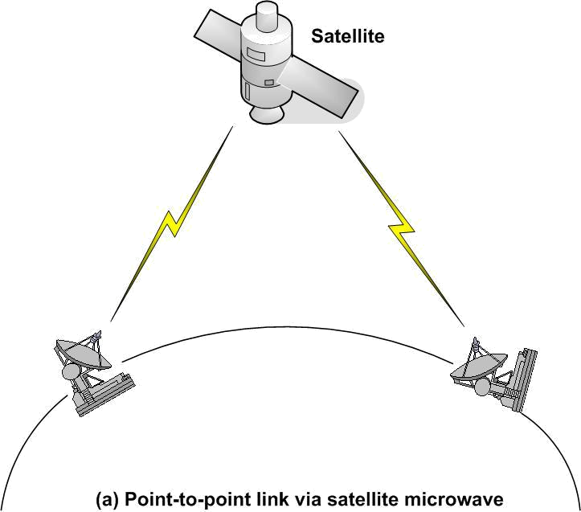

Figure 7 Satellite Microwave Communication: point –to- point
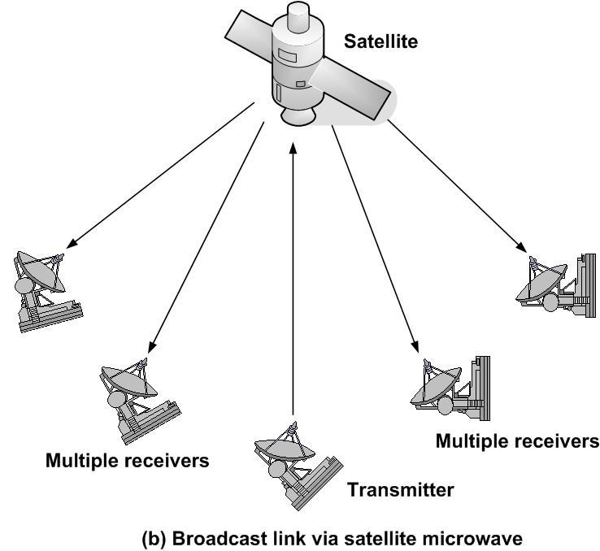

Figure 8 Satellite Microwave Communication: Broadcast links

Characteristics: Optimum frequency range for satellite communication is 1 to 10 GHz. The most popular frequency band is referred to as 4/6 band, which uses 3.7 to 4.2 GHz for down link and 5.925 to 6.425 for uplink transmissions. The 500 MHz bandwidth is usually split over a dozen transponders, each with 36 MHz bandwidth. Each 36 MHz bandwidth is shared by time division multiplexing. As this preferred band is already saturated, the next highest band available is referred to as 12/14 GHz. It uses 14 to 14.5GHz for upward transmission and 11.7 to 12.2 GHz for downward transmissions. Communication satellites have several unique properties. The most important is the long communication delay for the round trip (about 270 ms) because of the long distance (about 72,000 km) the signal has to travel between two earth stations. This poses a number of problems, which are to be tackled for successful and reliable communication.

Another interesting property of satellite communication is its broadcast capability. All stations under the downward beam can receive the transmission. It may be necessary to send encrypted data to protect against piracy.

Use : Now-a-days communication satellites are not only used to handle telephone, telex and television traffic over long distances, but are used to support various internet based services such as e-mail, FTP, World Wide Web (WWW), etc. New types of services, based on communication satellites, are emerging.

Comparison/contrast with other technologies:

- Propagation delay very high. On LANs, for example, propagation time is in nanoseconds -- essentially negligible.

- One of few alternatives to phone companies for long distances.
- Uses broadcast technology over a wide area - everyone on earth could receive a message at the same time!

- Easy to place unauthorized taps into signal.

Satellites have recently fallen out of favor relative to fiber.

However, fiber has one big disadvantage: no one has it coming into their house or building, whereas anyone can place an antenna on a roof and lease a satellite channel.

